**Master of Science (IT) Sem – 05**



LJ School Of Computer Applications

**Jay Hotel And Restaurant Management System**

GROUP NO:

03

Guided by:

Prof. VirendraSingh Ingle

Project By:

Chavda Harshil (22004500210032)

Chitaliya Het (22004500210035)

Thummar Kartik (22004500210278)

**Lj School Of Computer Applications**



Enrollment No: 22004500210278

This is certified that **Thummar Kartik** of Master of science (IT), Semester 05, Roll no **62** has satisfactorily completed his project titled **Restaurant Management system** under the supervision of internal guide.

Internal guide: HOD:

Dr. Virendra Ingle Dr. Jignesh Doshi

**Lj School Of Computer Applications**



Enrollment No: 22004500210035

This is certified that **Chitaliya Het** of Master of science (IT), Semester 05, Roll no **06** has satisfactorily completed his project titled **Restaurant Management system** under the supervision of internal guide.

Internal guide: HOD:

Dr. Virendra Ingle Dr. Jignesh Doshi

**Lj School Of Computer Applications**



Enrollment No: 22004500210032

This is certified that **Chavda Harshil** of Master of science (IT), Semester 05, Roll no **06** has satisfactorily completed his project titled **Restaurant Management system** under the supervision of internal guide.

Internal guide: HOD:

Dr. Virendra Ingle Dr. Jignesh Doshi

1. Introduction

* Restaurant management system is built to connect and provide a medium so that users can get the services from them palm
* A restaurant management system is a software solution designed to optimize various aspects of resort availability and administration. It encompasses tools and processes for managing customer records, manage staff, booking and verifying the process of managing order tasks…

1.1 Existing System

# A restaurant management system which provides solutions in regards to streamline and automate various operations and processes within a restaurant or hospitality establishment.

# It encompasses a range of functions to efficiently manage reservations, guest services, room assignments, inventory, billing, reporting, and more.

1.2 Need for New System

* The system allows to check for room reservations, advance bookings, current bookings, free rooms, status of the restaurant or party hall in the resort and also the hotel staff payment status through SMS messages. It notifies the system administrator about expiring staff contracts and payment dates in advance.

1.3 Objective for New System

* System provides effective platform by which users can easily utilize the system and get better benefits from the system. With the help of this system, users are able to use their resources optimistically.
* System provides effective platform by which users can easily utilize the system and get better benefits from the system. With the help of this system, users are able to use their resources optimistically.

1.4 Problem Definition

* A Restaurant management system aims to enhance customer care, increase efficiency, and ensure data security and privacy. Providing prompt access to correct customer information, administrative processes can improve quality, treatment, and follow-up care. Implementing strong security measures. Customer should be empowered to take part actively.

1.5 Core components

1.6 Project Profile

|  |  |  |
| --- | --- | --- |
| Project name | | Restaurant system |
| **Front-end** | | HTML5, CSS3, JavaScript, Bootstrap |
| **Back-end** | **Database** | XAMPP |
| **Framework** | Django |

1.7 Assumptions & Constraints

* Assumptions:  
    
  - We assume that sources or customer provide reliable and trustable health information.  
  - We also assume that sources follow regulations & protection laws on website.

-All the parties are having a knowledge of technical parameters of website/application

* Constraints

- No Backup services

- Supported English language only

-unable to get full access

1.8 Advantages & Limitations

2.1 Requirement Determination

* Requirement determination for resort management project involves gathering, analyzing, and documenting the needs and expectations of stakeholders.
* This phase is consisting of:
  + Surveys & sampling
  + Client’s requirements
  + Identifying the non-functional requirements
  + Review existing system if available
  + References
    - https://www.makemytrip.in/
    - https://www.goibibo.com/

2.2 Targeted Users

* Admin
* User
* Staff

3.0 System Design

**3.1 Use case diagram**

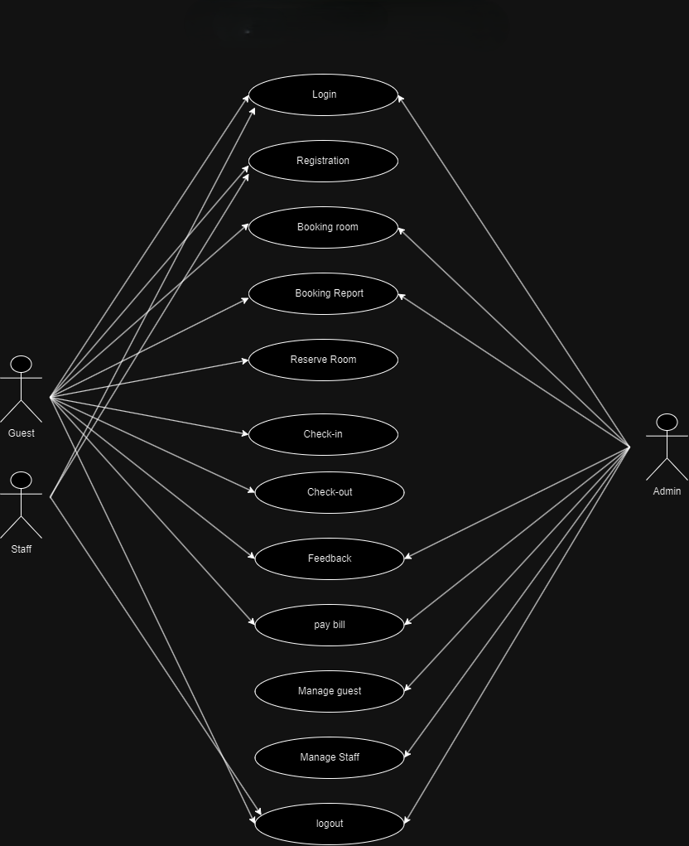

Reastaurant Management System

**3.2 Class Diagram**

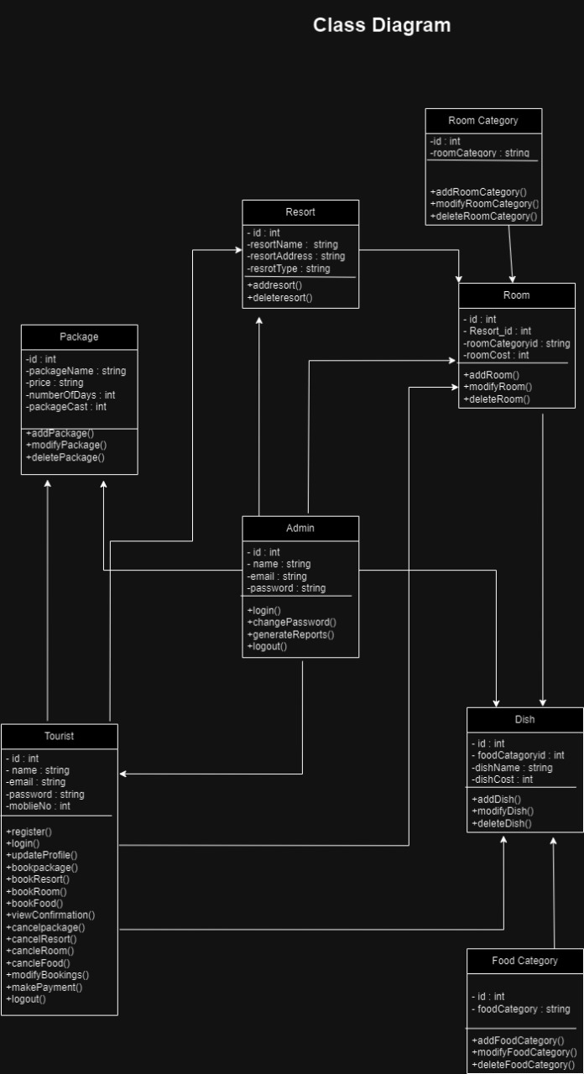

**3.3 Sequence Diagram**

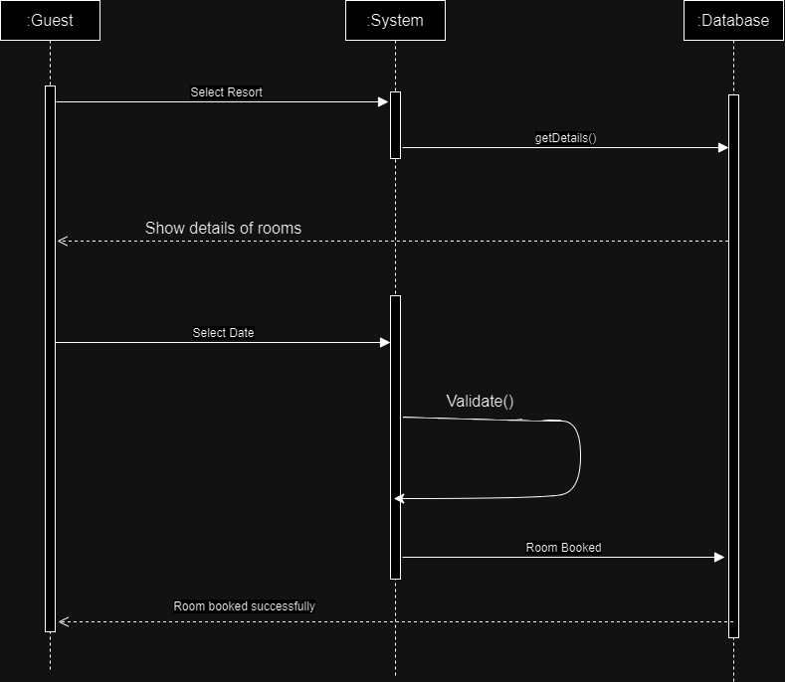

**Sequence DIAGRAM**

**3.4 Activity Diagram**

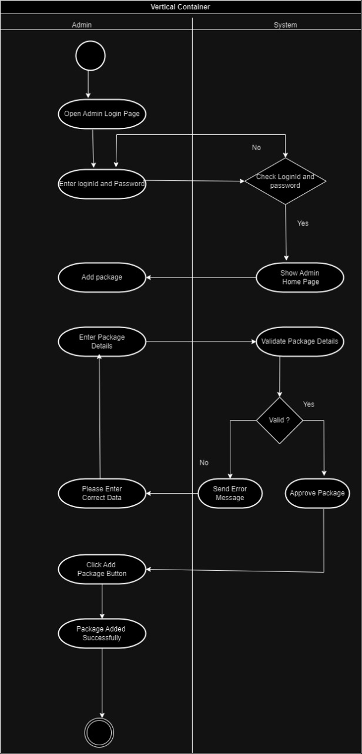

**ACTIVITY DIAGRAM**

3.5 Data Dictionary

**User table**

|  |  |  |  |  |
| --- | --- | --- | --- | --- |
| Field | Datatype | Constraints | Description | Sample |
| Username | Varchar2(25) | primary key | Username | kartik7516 |
| First name | Varchar2(25) | Not null | First name of the user | kartik |
| Last name | Varchar2(25) | Not null | Last name of the user | Thummar |
| Email | Varchar2(25) | Unique | Email of the user | [abc@gmail.com](mailto:abc@gmail.com) |
| Password | Varchar2(10) | Not null | Password | abc@123 |
| Password Confirmation | Varchar2(50) | Not null | Password Confirmation | abc@123 |

**Forget Password**

|  |  |  |  |  |
| --- | --- | --- | --- | --- |
| Field | Datatype | Constraints | Description | Sample |
| Email | Varchar2(25) | Unique | Email of the user | [abc@gmail.com](mailto:abc@gmail.com) |
| Otp | Int(4) | Unique | Enter the otp | 1045 |
| Password | Varchar2(10) | Not null | Password | abc@123 |
| Password Confirmation | Varchar2(50) | Not null | Password Confirmation | abc@123 |

**Add room**

|  |  |  |  |  |
| --- | --- | --- | --- | --- |
| Field | Datatype | Constraints | Description | Sample |
| Room no. | Int(4) | primary key | Add the room number | 123 |
| Room type | Varchar2(25) | Not null | Enter the room type | Royal |
| Room price | Int(5) | Not null | Enter the room price | 2000 |

|  |  |  |  |  |
| --- | --- | --- | --- | --- |
| Field | Datatype | Constraints | Description | Sample |
| Name | Varchar2 | primary key | Name of staff member | jay |
| Email | Varchar2 | Not null | Email of staff member | jay@gmail.com |
| Phone | Int(10) | Not null | Phone.no of staff member | 8522588525 |
| Experience | Int(2) | Not null | Experience of staff member | [3](mailto:abc@gmail.com) |
| Specialization | Varchar2 | Not null | Staff member of specialization | Cooking |

**Staff table**

**Cafeteria table**

|  |  |  |  |  |
| --- | --- | --- | --- | --- |
| Field | Datatype | Constraints | Description | Sample |
| menu_id | INT | primary key | Unique identifier for the menu | 1 |
| item_name | VARCHAR(50) | Not null | Name of the menu item | Burger & Cold drink |
| Description | TEXT | Not null | Description of the menu item | It’s a combo . |
| Price | DECIMAL(10,2) | Not null | Price of the menu item | 195 |

**Billing table**

|  |  |  |  |  |
| --- | --- | --- | --- | --- |
| Field | Datatype | Constraints | Description | Sample |
| Id | Int(4) | primary key | Table id | 1 |
| Userid | Int(4) | Foreign key references user table | Id of the user | 2 |
| Date | Date | Not null | Date of the bill | 20-04-2024 |
| Discount | Decimal(6,2) | Not null | Discount price on bill | 2500/- |
| Total_amount | Decimal(6,2) | Not null | Amount of the bill | 9980/- |
| Payment_id | Int(10) | Foreign key references payment table | Payment id | 15002693 |

**Payment table**

|  |  |  |  |  |
| --- | --- | --- | --- | --- |
| Field | Datatype | Constraints | Description | Sample |
| Id | Int(4) | primary key | Table id | 1 |
| Userid | Int(4) | Foreign key references user table | Id of the user | 2 |
| Date | Date | Not null | Date of the payment | 20-04-2024 |
| Status | Varchar2(15) | Not null | Status of the payment | Pending |
| Payment_method | Varchar2(10) | Not null | Method of the payment | Cash |

**Feedback table**

**Blog table**

|  |  |  |  |  |
| --- | --- | --- | --- | --- |
| Field | Datatype | Constraints | Description | Sample |
| Id | Int(4) | primary key | Table id | 1 |
| Userid | Int(4) | Foreign key references user table | Id of the user | 2 |
| Date | Date | Not null | Date of the feedback received | 20-04-2024 |
| Message | Varchar2(250) | Not null | Message description | It was good |

4. Development

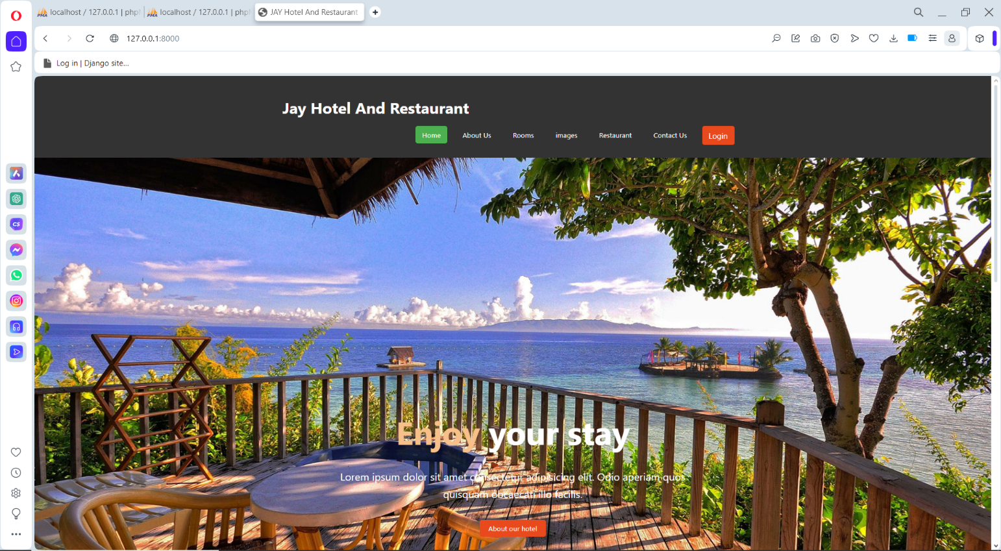4.1 Screenshots

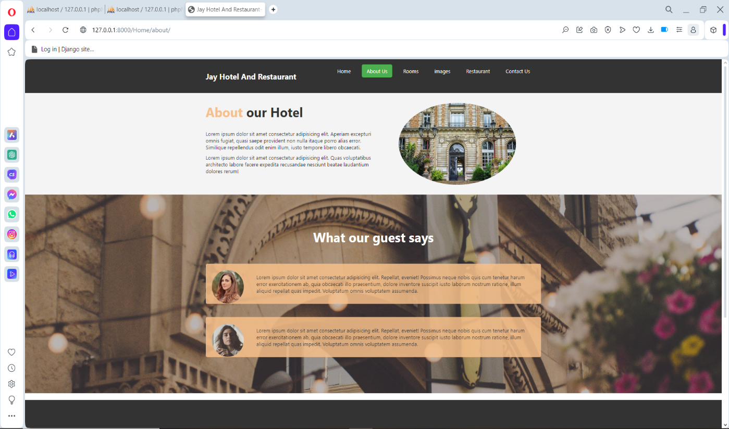

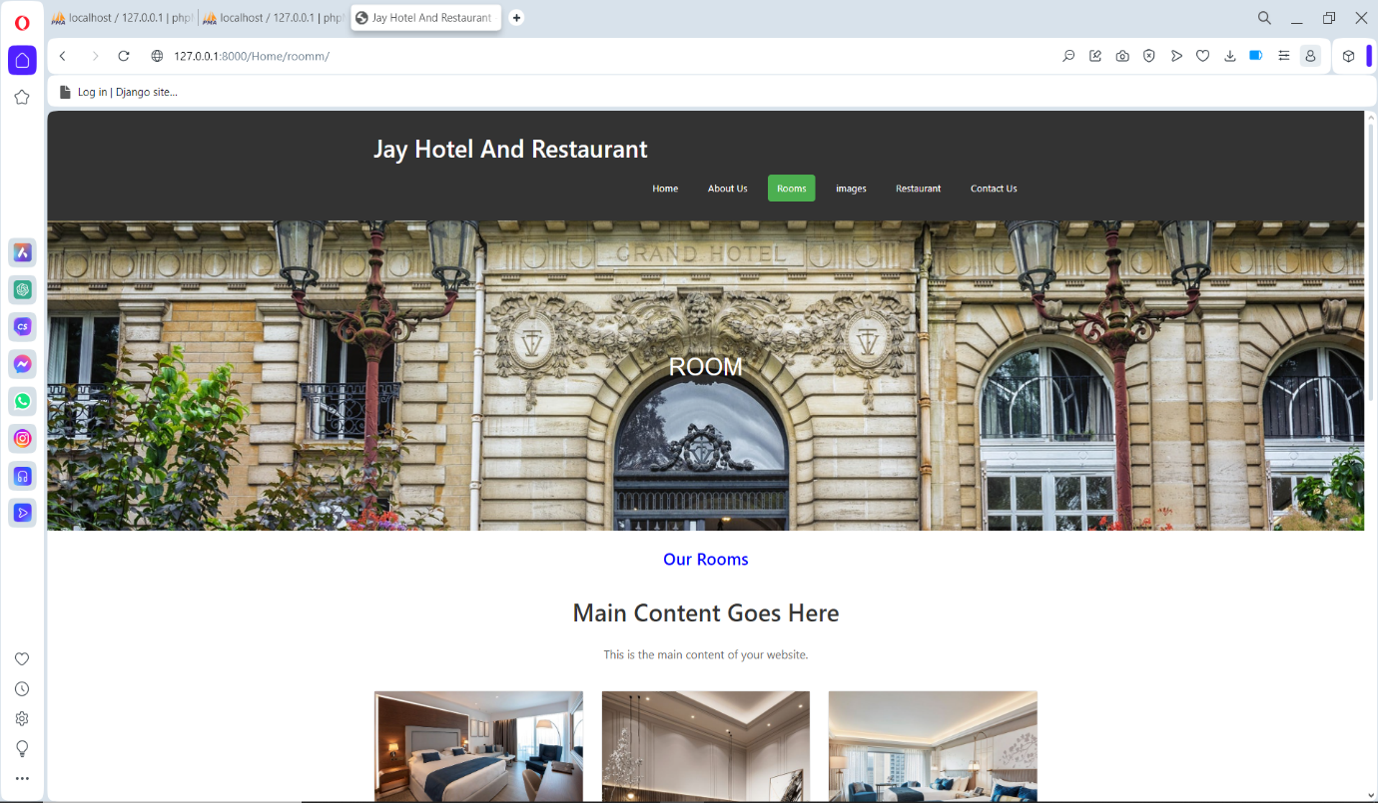

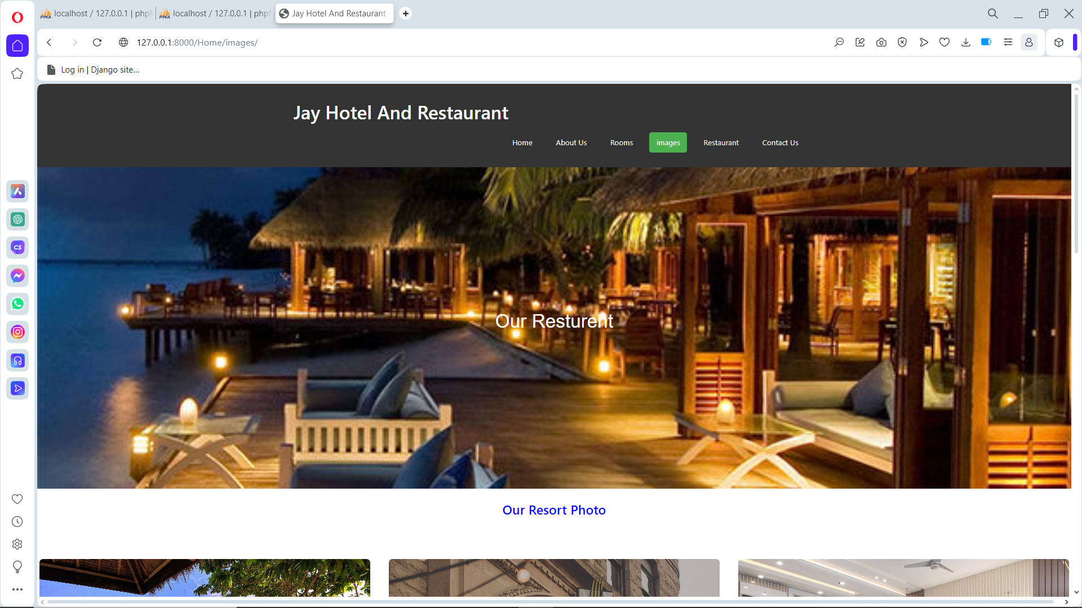

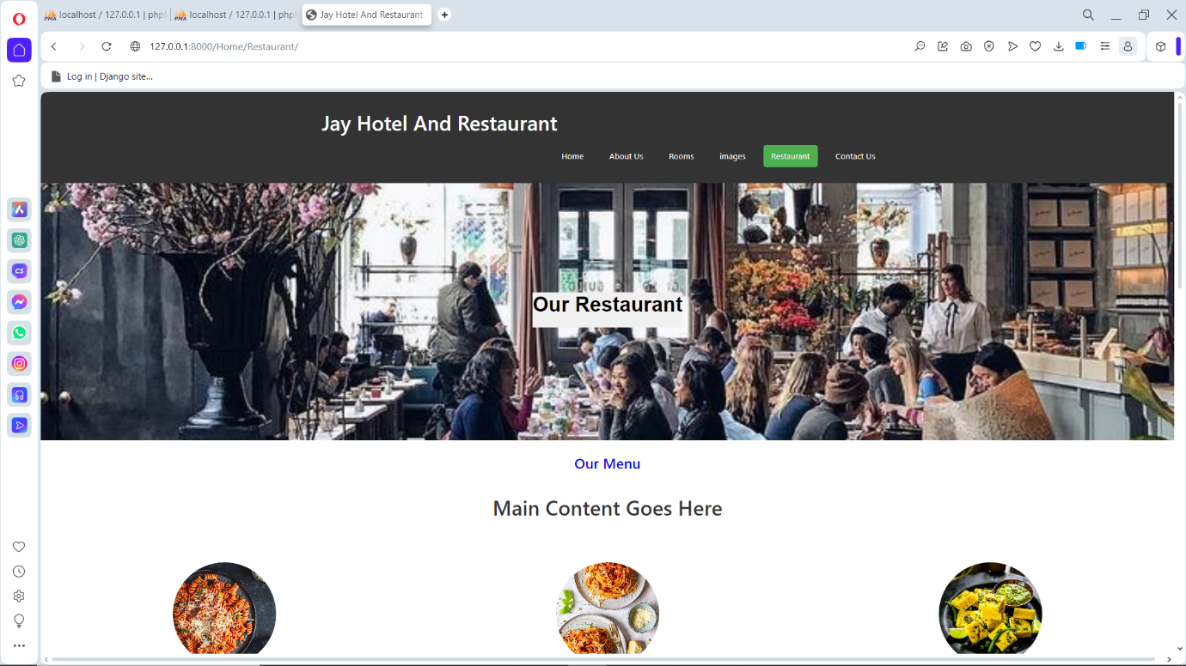

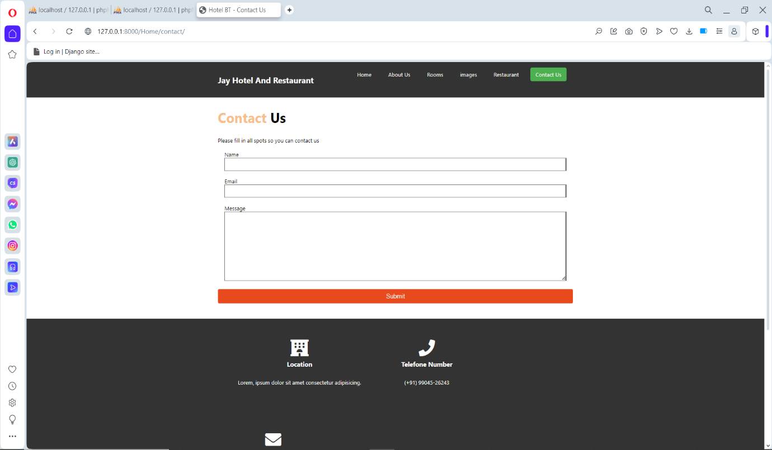

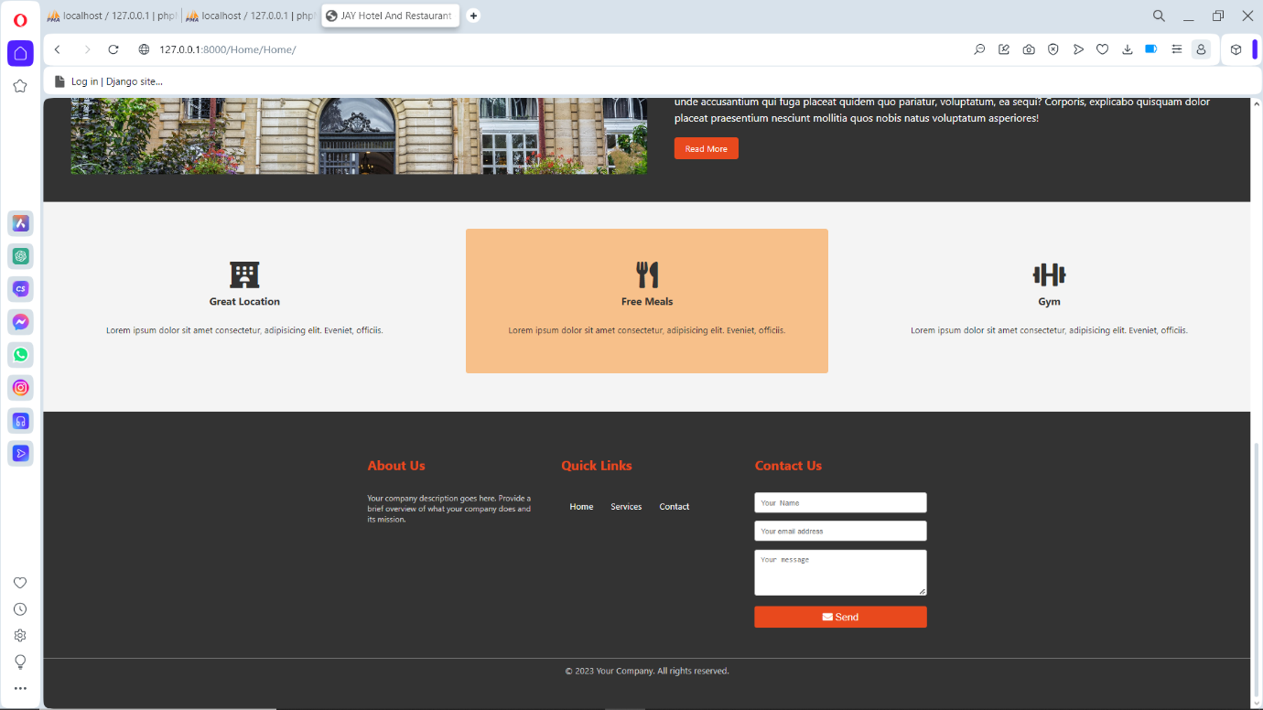

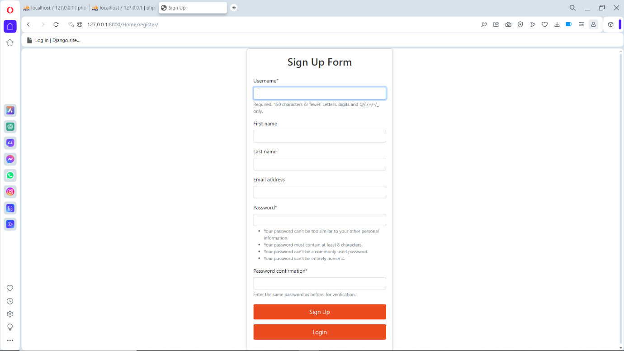

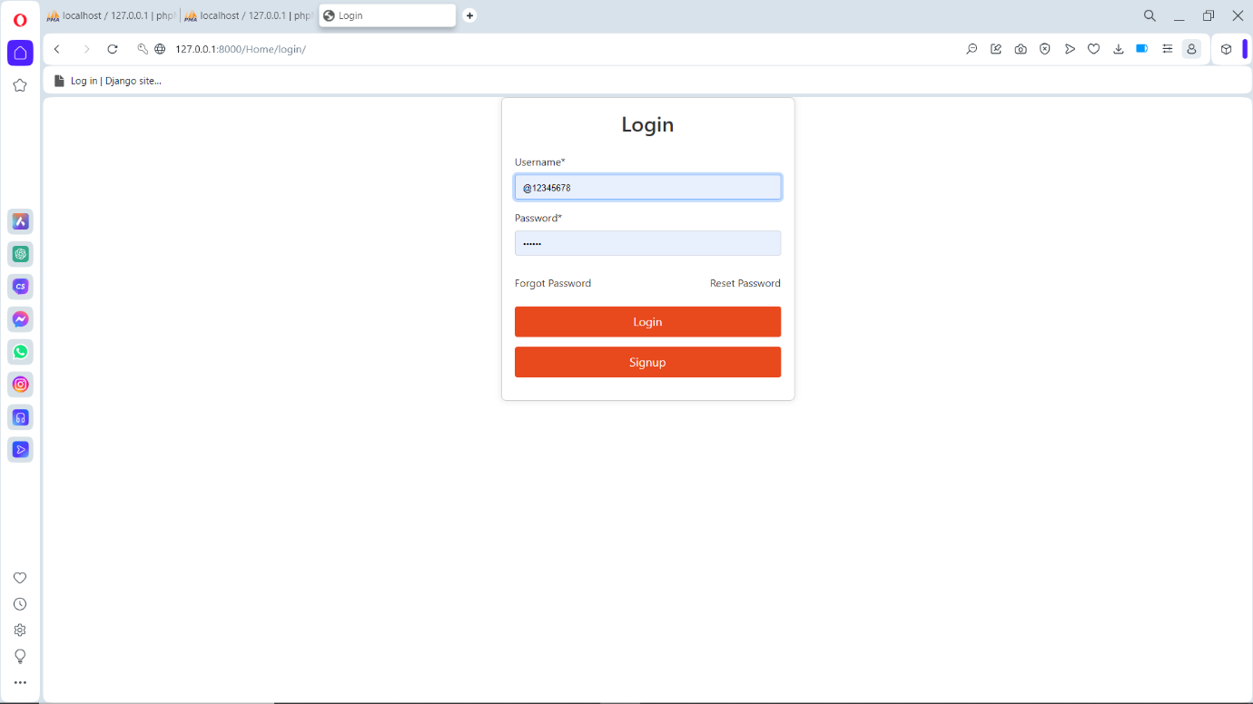

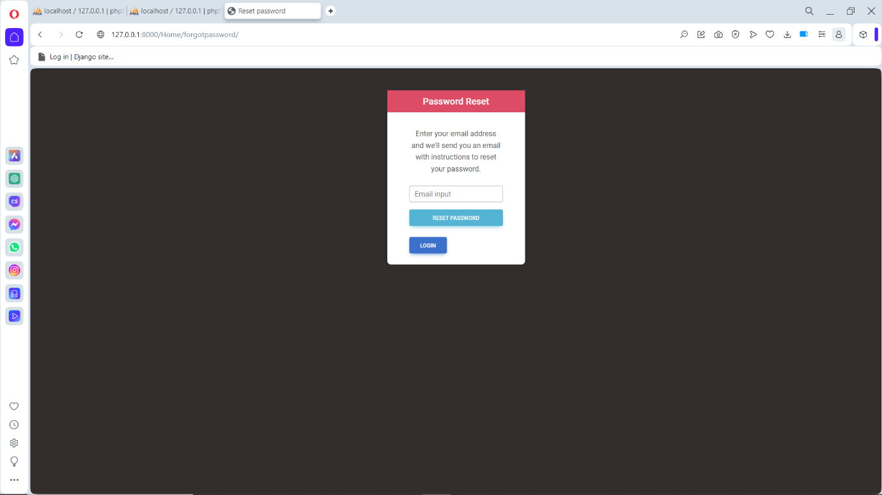

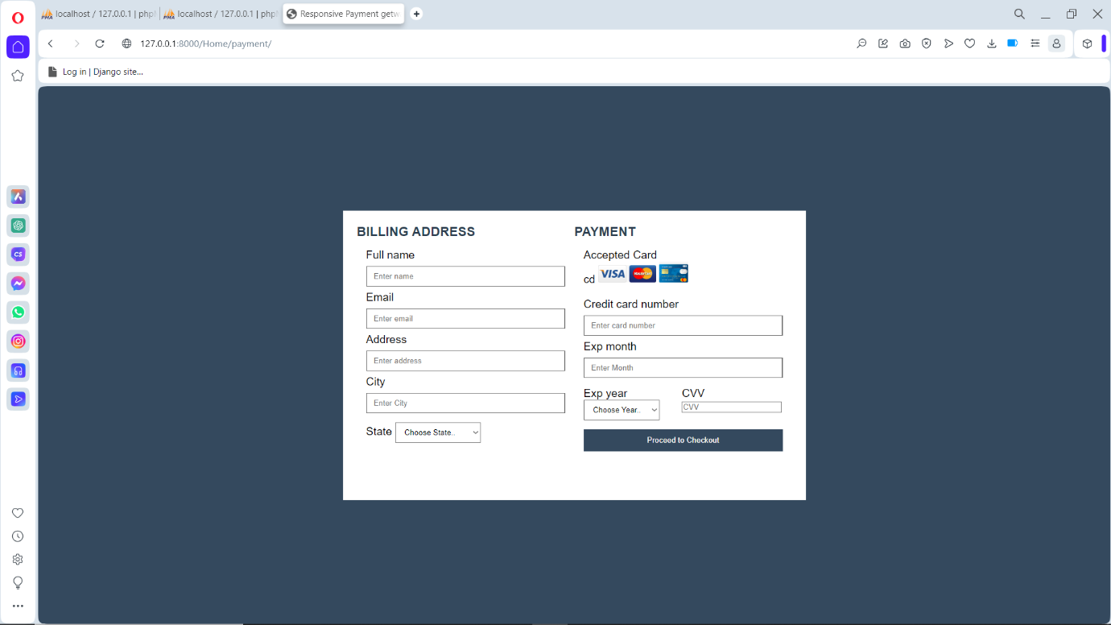

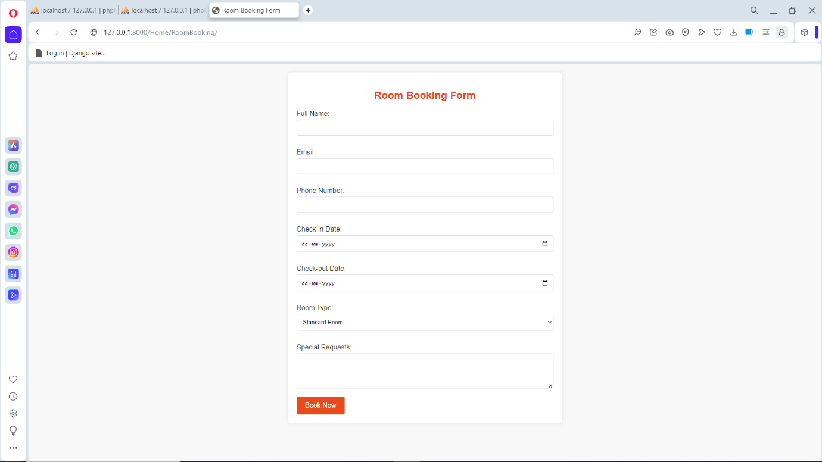

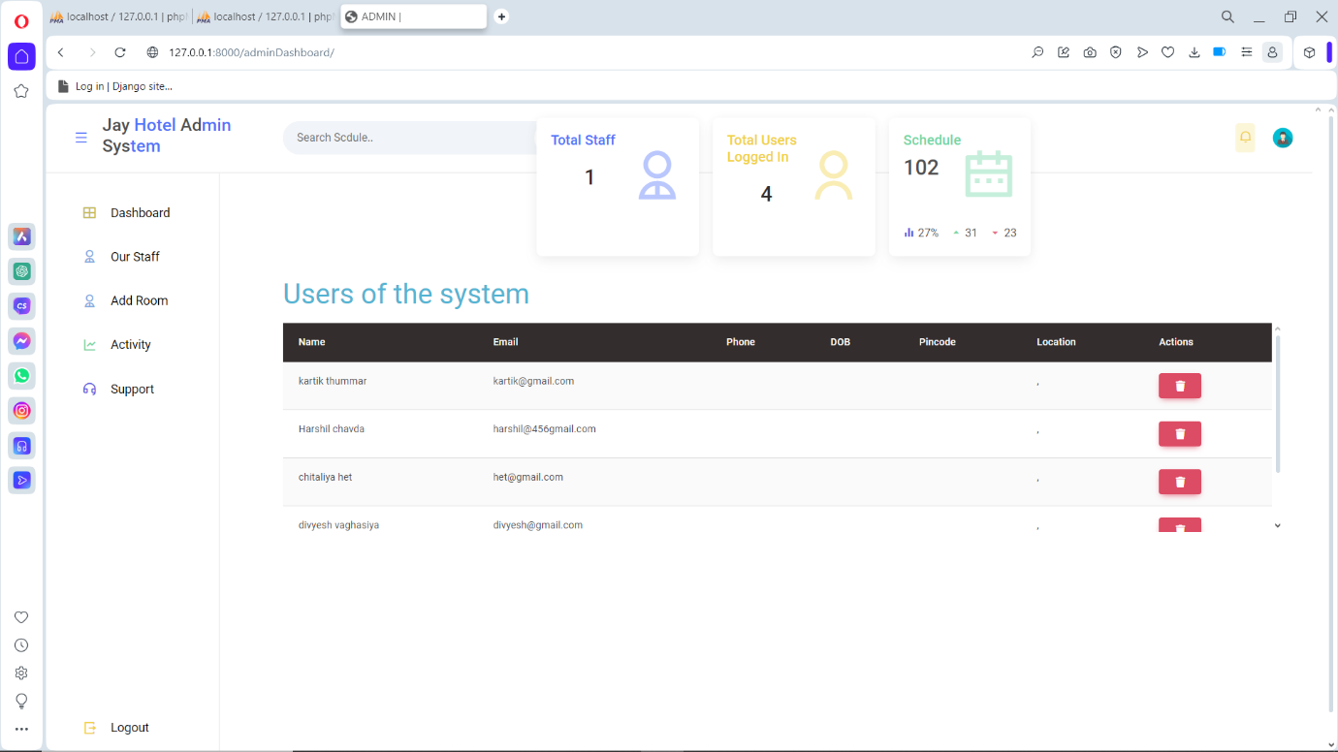

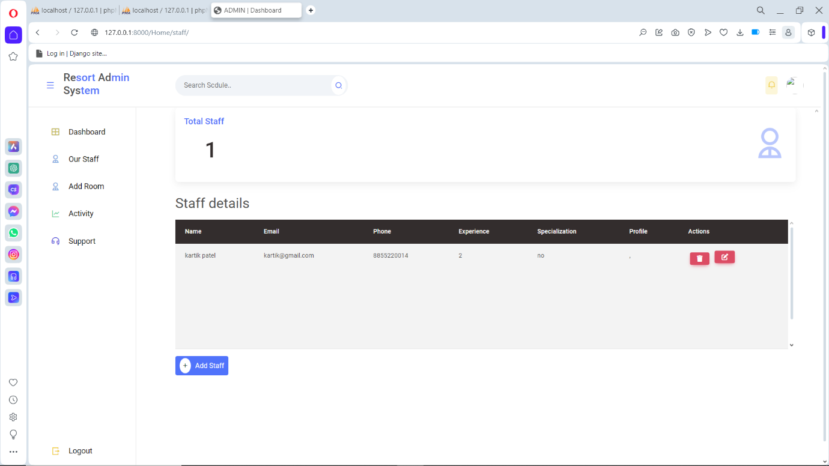

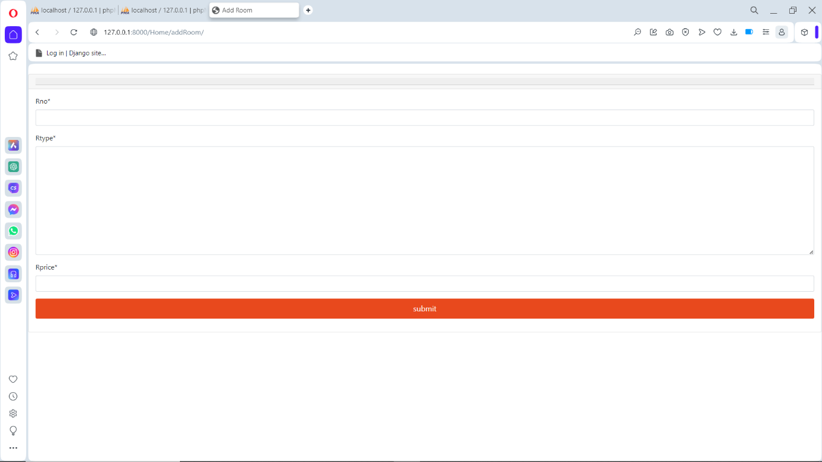

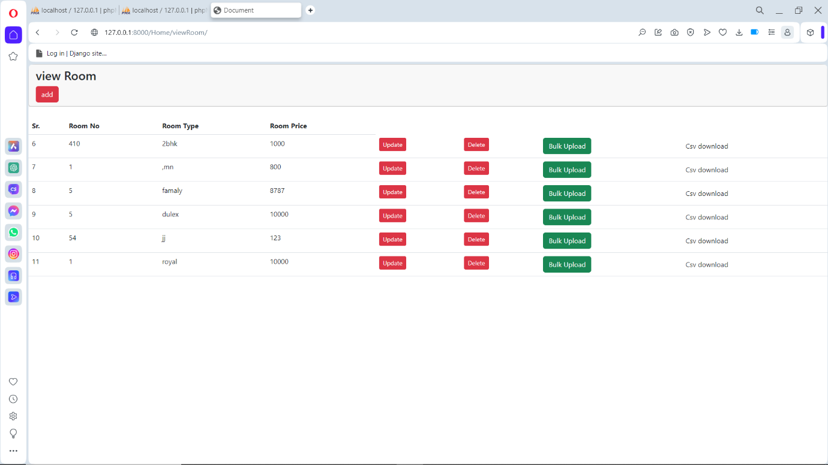

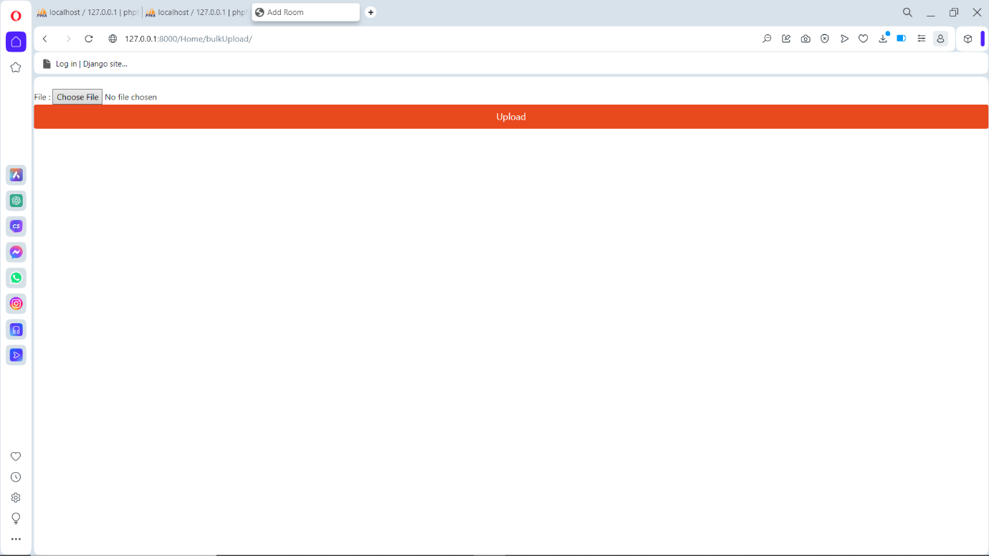

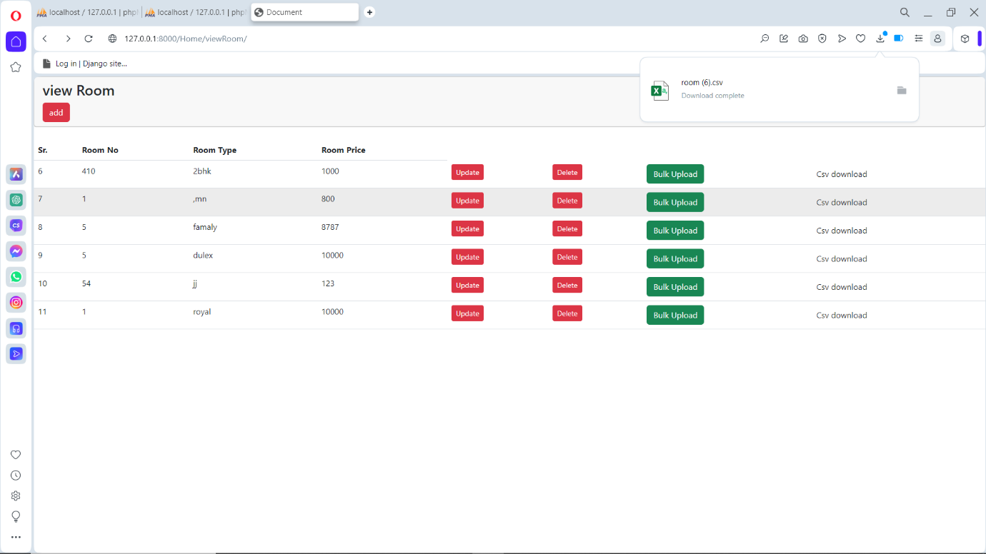

Agile Document

5.1 Agile Project charter

### 

5.2 Agile Sprint blog

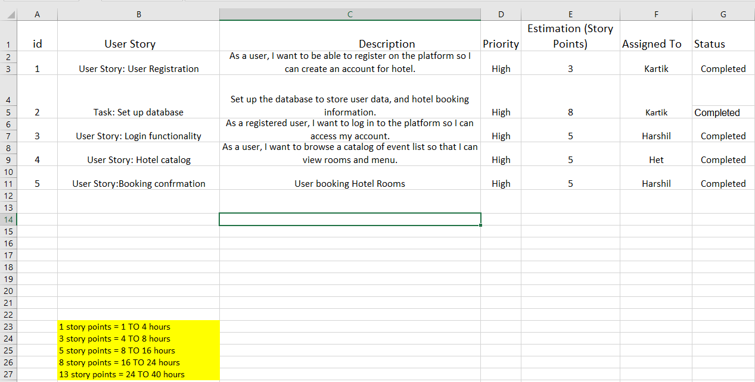

5.3 Project Roadmap/Schedule

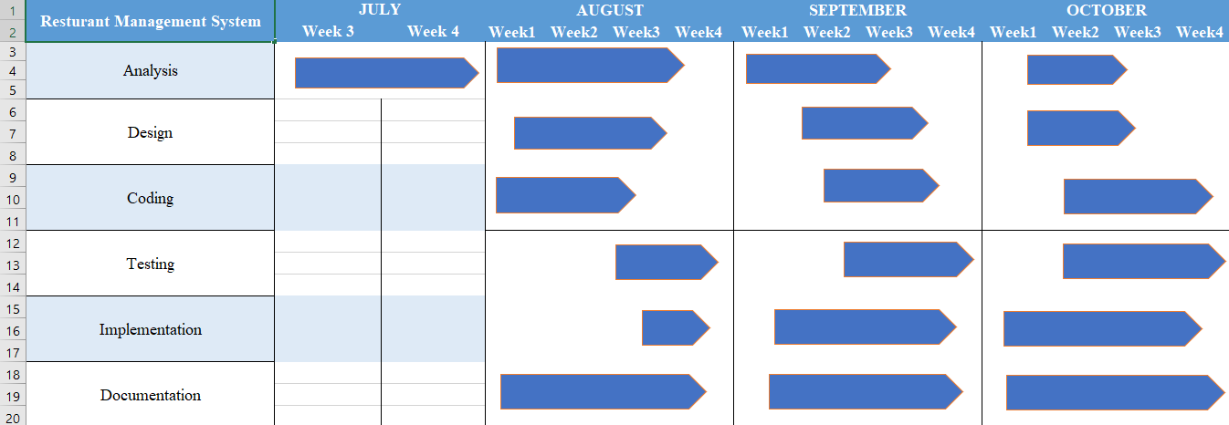

5.4 User Story

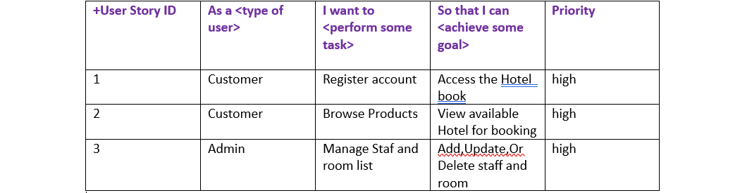

Proposed Enhancements

* Restaurant management systems should focus on resolving current issues and enhancing functionality. Improvements include integrating with EHR systems, improving data security, using machine learning and AI, and integrating telemedicine. Access control and advanced encryption techniques can protect patient data. Mobile applications can help monitor patients remotely and communicate with them in real time.

Conclusion

* A Restaurant management system is essential for improving consumer facility , operational effectiveness, data security, and regulatory compliance. It promotes the implementation of cutting-edge technologies, facilitates the seamless sharing of patient data, and helps with cost management.